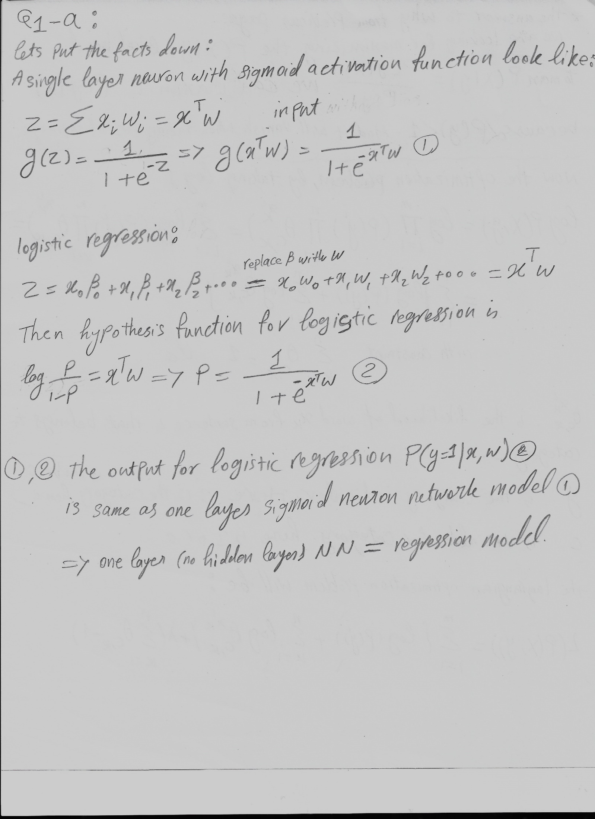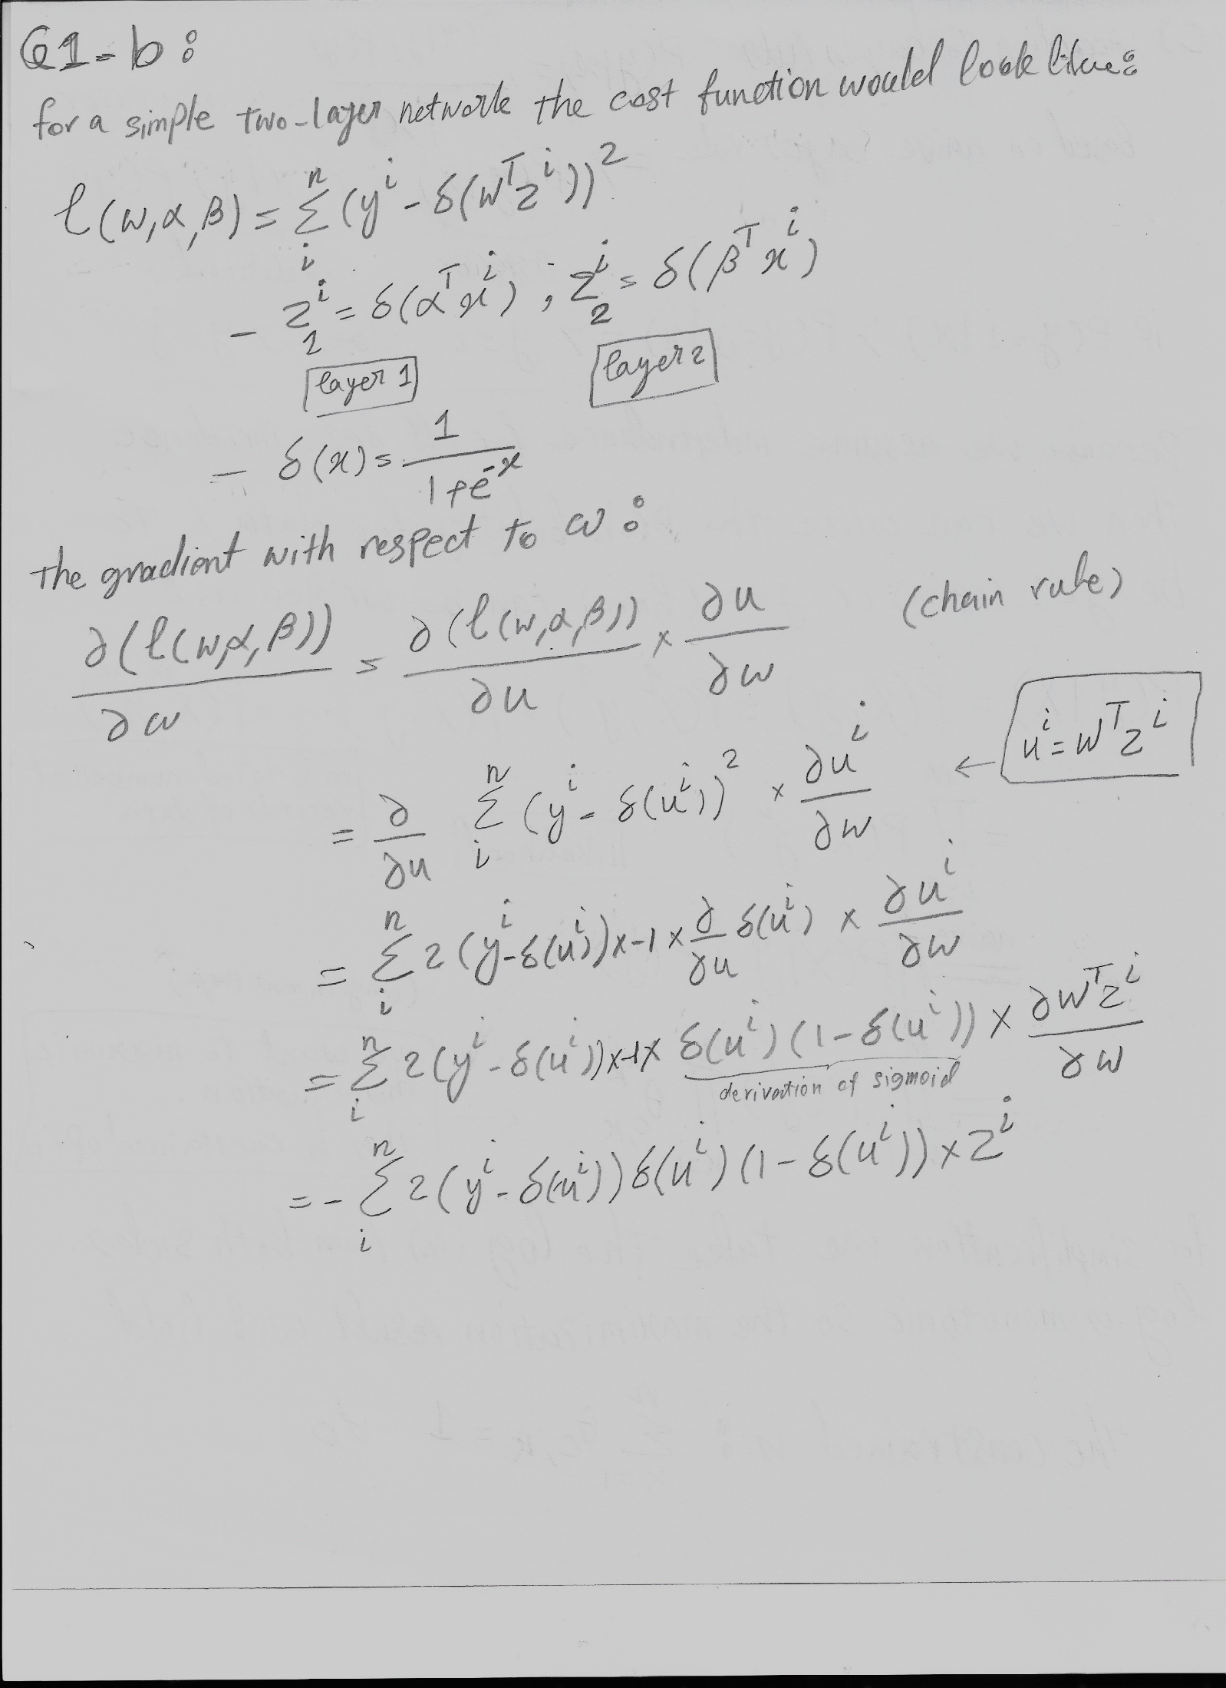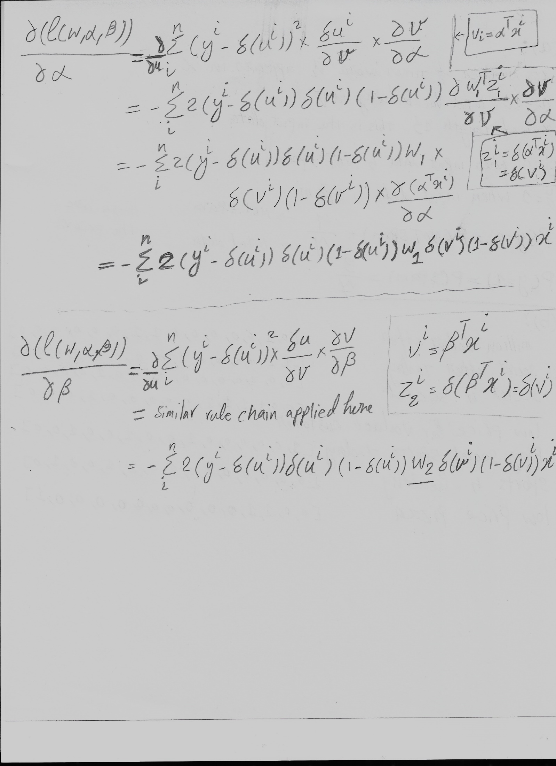

# Q2 – Part One (a)

In this report, I assume that performance is translated into accuracy. Higher accuracy, higher performance.

Report of testing accuracy for **support vector machine** with kernel “Radial Basis Function” (rbf) and gamma to auto. The accuracy of SVM is 97% for the **test data (20%).**

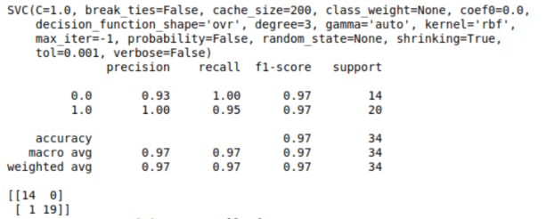

The accuracy for the **entire data** using the SVM is 99%

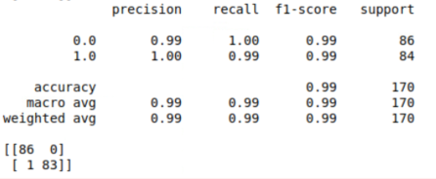

Report of testing accuracy for simple **neural network** with hidden layers (5, 2), activation function “Relu”, is **100%**. The model managed classify all 34 data records correctly.

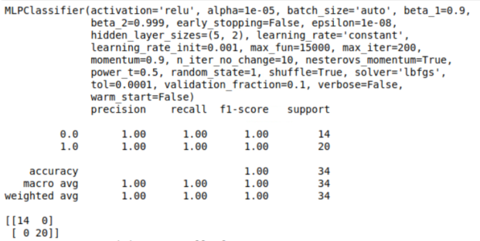

The accuracy decreases to 99% when we test the model on the entire data. There was only one miss classification only.

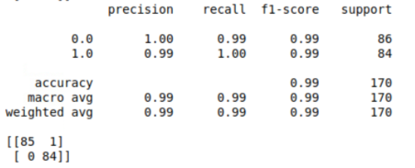

**Conclusion:** neural network model performed better than SVM and this result was shown by 100% accuracy on the test data. Nevertheless, when we test both on the entire data set, they get similar overall accuracy. All in all, neural network performs better on high dimensional data such as the “divorce predictors” data set which has 55 attributes. Specifically, that we can tweak the neural network model with various activation functions and hidden layers.

# Q2 – Part one (b)

The decision boundary for SVM is as below. We are using a kernelized SVM with **Gaussian RBF** in which is a function whose value depends on the distance from the origin. And we also used **Gamma** which is a parameter of Gaussian Kernel to handle non-linear classification. Hence, we see the decision boundary is also non-linear.

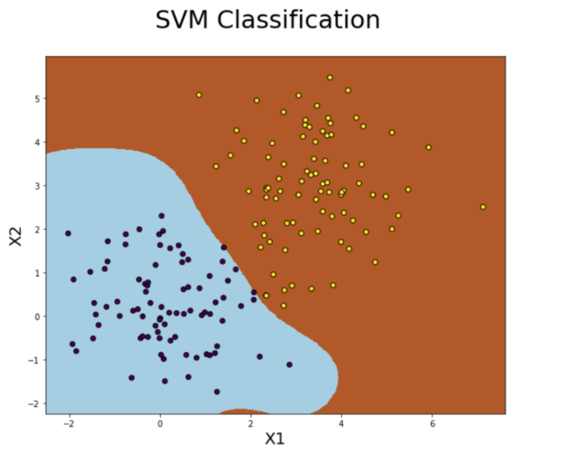

On the other hand, for Neural Network model, we are using “Relu” as activation function. This is a non-linear activation function and due to its nature, Relu function has sharp boundaries. Hence, we see this non-smooth non-linear classification boundaries for our neural network model.

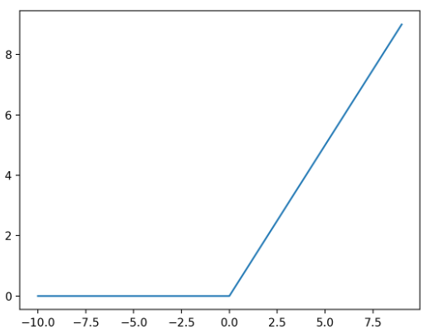

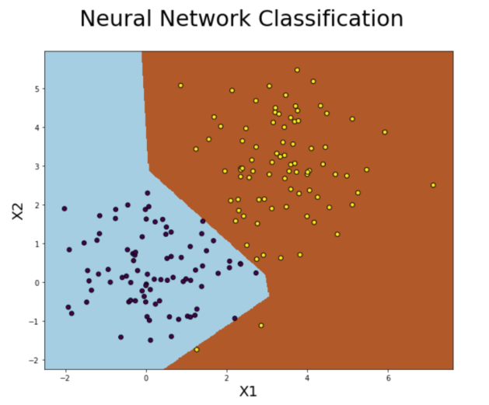

**Conclusion:** The shape of decision boundary for both SVM and Neural Network depends on the type of function we use for activation (in case of NN) and Kernel (in case of SVM). Relu, due to its nature, produces sharp decision boundaries and we RBF created smoother one. Depends on the nature of activation function we can generate decision boundaries with smoother edges. That said, even with the current state of our neural network model, the precision is very impressive.

# Q2 – Part Two (a)

In this section we are going to do classification on data with more dimension compared to the one in Part One. Here the data has 784 properties.

Report of testing accuracy for **support vector machine** with kernel “Radial Basis Function” (rbf) and gamma to auto. The accuracy of SVM is 98% for the **test data (20%).**

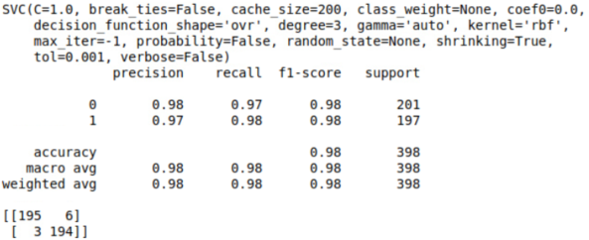

The accuracy for the **entire data** using the SVM is 98%. This reasonable that we are dividing our data and we have enough data in the test set that represents the entire data.

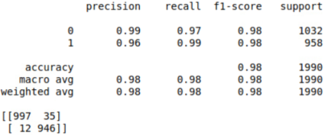

Report of testing accuracy for simple **neural network** with hidden layers (5, 2), activation function “Relu”, is **99%**. The model managed classify all 34 data records correctly.

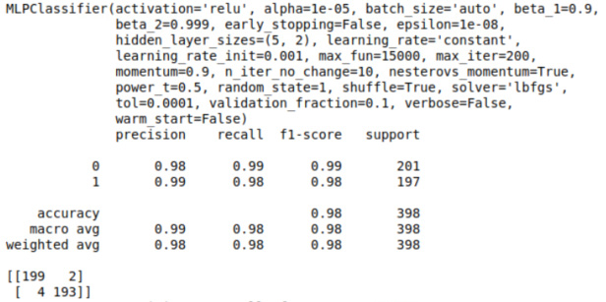

The accuracy decreases to 100% when we test the model on the entire data. There was only 6 miss classification only. But compare to total number of data we have, the accuracy is 100%.

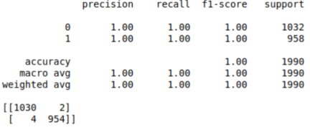

**Conclusion:** neural network model performed better than SVM for MNIST data set both with the test data and the entire data. Overall, neural network performs with high accuracy with respect to large dimensional data. The conclusion is like Part One.

# Q2 – Part Two (b)

The decision boundary for SVM for the first two PCA dimension is as below. Here, similar to Part One, We are using a kernelized SVM with **Gaussian RBF** in which is a function whose value depends on the distance from the origin. And we also used **Gamma** which is a parameter of Gaussian Kernel to handle non-linear classification. Hence, we see the decision boundary is also non-linear.

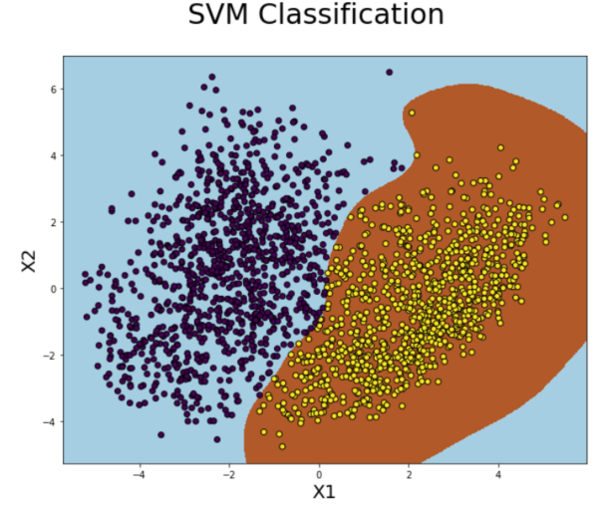

On the other hand, for Neural Network model, again we are using “Relu” as activation function. Relu is a non-linear activation function and due to its nature that Relu function has sharp boundaries. Hence, we see this non-smooth non-linear classification boundaries for our neural network model.

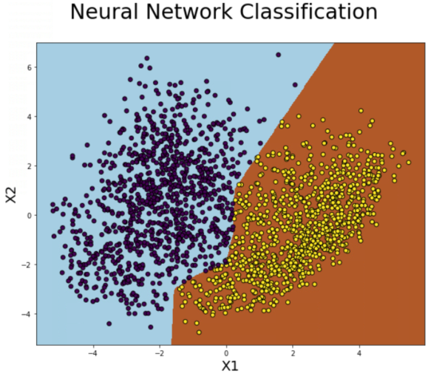

**Conclusion:** {Similar to Part One (b)} The shape of decision boundary for both SVM and Neural Network depends on the type of function we use for activation (in case of NN) and Kernel (in case of SVM). Relu, due to its nature, produces sharp decision boundaries and we RBF created smoother one. Depends on the nature of activation function we can generate decision boundaries with smoother edges. That said, even with the current state of our neural network model, the precision is very impressive.

# Q3-(a)

For this section I used Excel to do all my calculations for epsilon, alpha, Z, and the weight of each data point in each iteration. The final answers are in the table below and the excel sheet is attached to the final report (Zip file):



Please check the excel sheet to follow all the calculations based on AdaBoost algorithm.

